Samsung 870 EVO 1TB SSD SATA 2.5&quot; - MZ-77E1T0

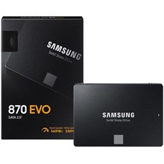

**Key Specifications:**

* **Capacity**: 1TB
* **Interface**: SATA III (6Gb/s), backward compatible with SATA II and SATA I
* **Form Factor**: 2.5"
* **Sequential Read Speed**: Up to 560 MB/s
* **Sequential Write Speed**: Up to 530 MB/s

**Performance Features:**

* **Intelligent TurboWrite Technology**:  
  Boosts write speeds for enhanced performance during demanding tasks.
* **Optimized for Everyday Use**:  
  Ensures smoother system responsiveness for multitasking, gaming, and multimedia applications.

**Advanced Technology**

* **Samsung V-NAND Technology**:  
  Delivers faster performance, greater reliability, and lower power consumption.
* **Samsung MKX Controller**:  
  Custom-designed to optimize storage operations and performance efficiency.

**Warranty:**

* Backed by a **5-year limited warranty**, providing long-term peace of mind.